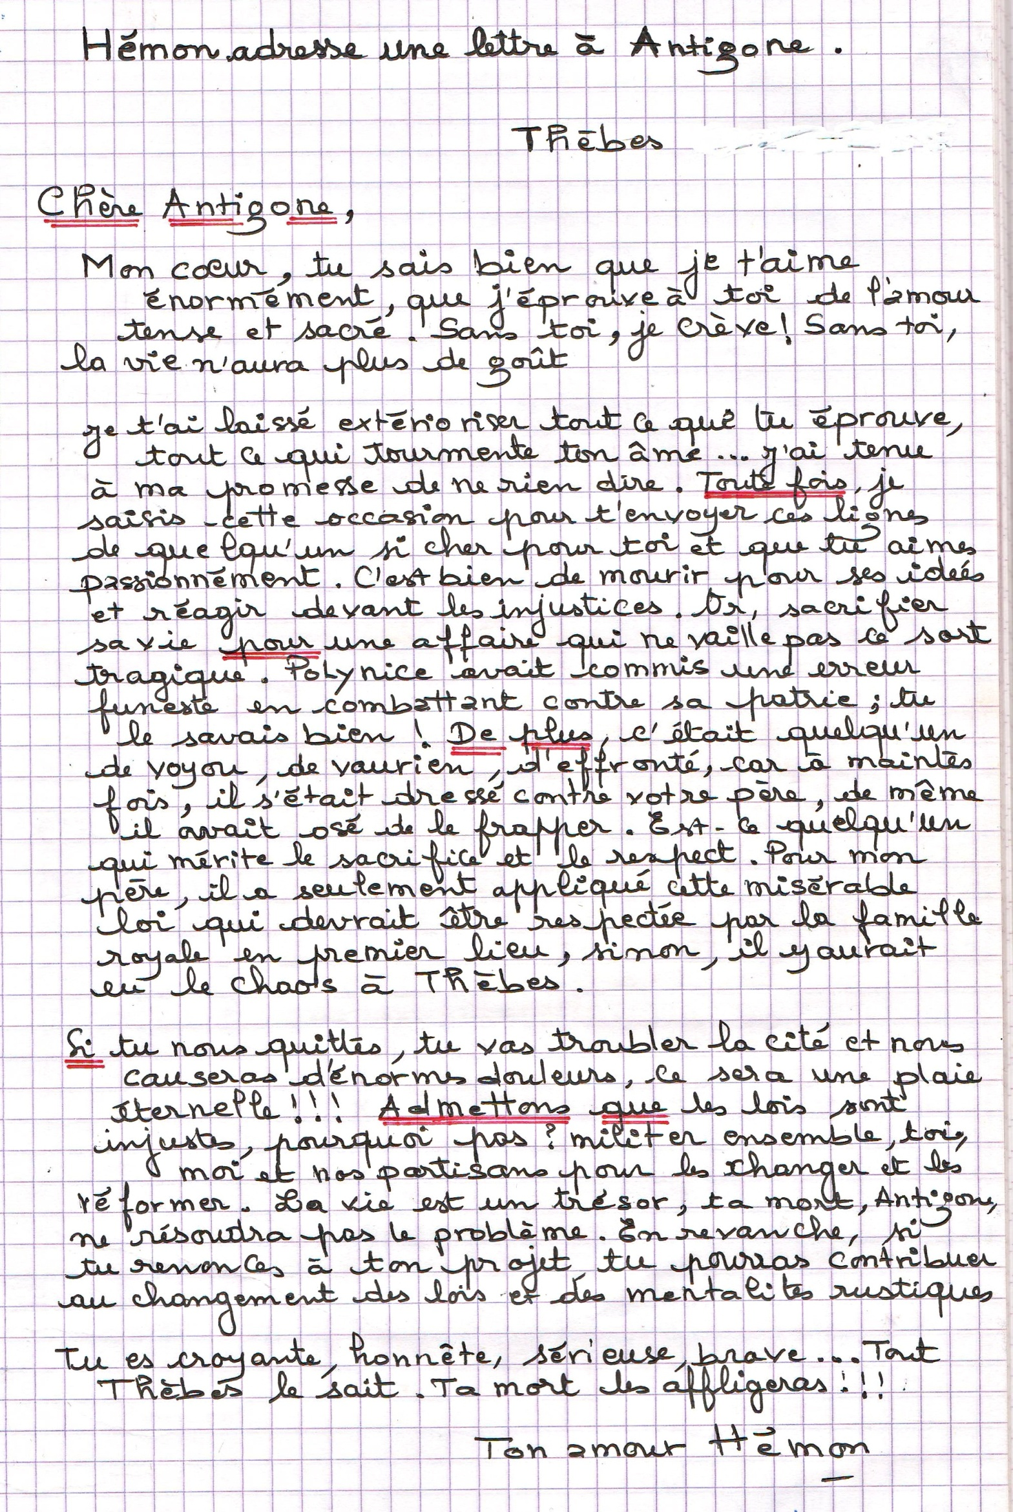
Mr ABDERRAHIM CHARAFI chararose.e-monsite.com 06 77 84 31 42

